4.import pandas as pd
import matplotlib.pyplot as plt
data = {
"Date": ["2020-01-01","2020-01-02","2020-01-03","2020-01-04","2020-01-05"],
"Close": [1367,1375,1382,1390,1401]
}
df = pd.DataFrame(data)
df["Date"] = pd.to_datetime(df["Date"])
plt.plot(df["Date"], df["Close"], marker="o")
plt.title("Alphabet Stock Prices")
plt.xlabel("Date")
plt.ylabel("Closing Price")
plt.grid(True)
plt.show()

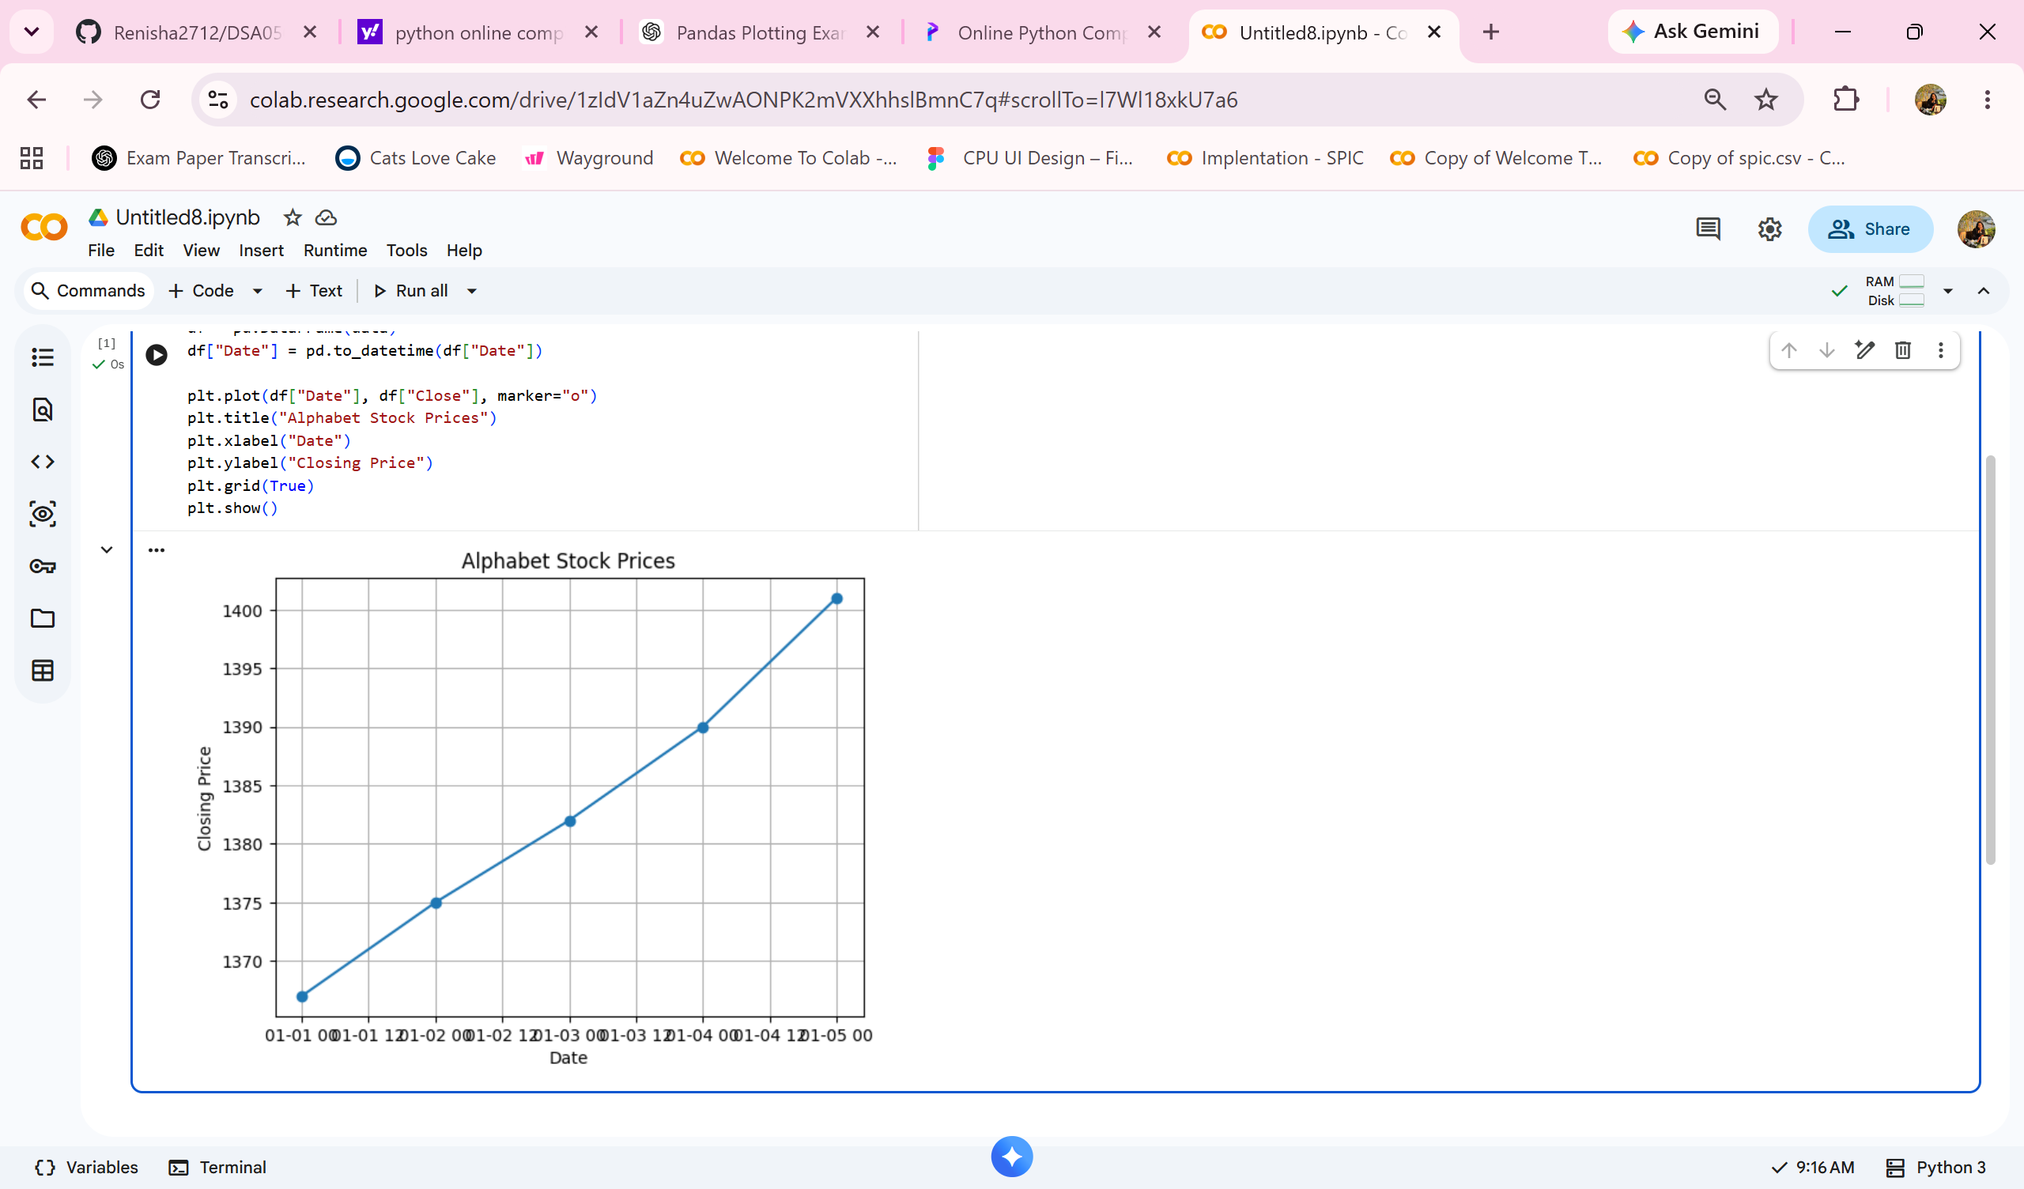

5.Import pandas as pd
import matplotlib.pyplot as plt
data = {
"Date": ["2020-01-01","2020-01-02","2020-01-03","2020-01-04","2020-01-05"],
"Volume": [1500000, 1800000, 1700000, 2100000, 1900000]
}
df = pd.DataFrame(data)
df["Date"] = pd.to_datetime(df["Date"])
plt.figure(figsize=(8,5))
plt.bar(df["Date"], df["Volume"])
plt.title("Trading Volume of Alphabet Inc.")
plt.xlabel("Date")
plt.ylabel("Volume")
plt.xticks(rotation=45)
plt.show()

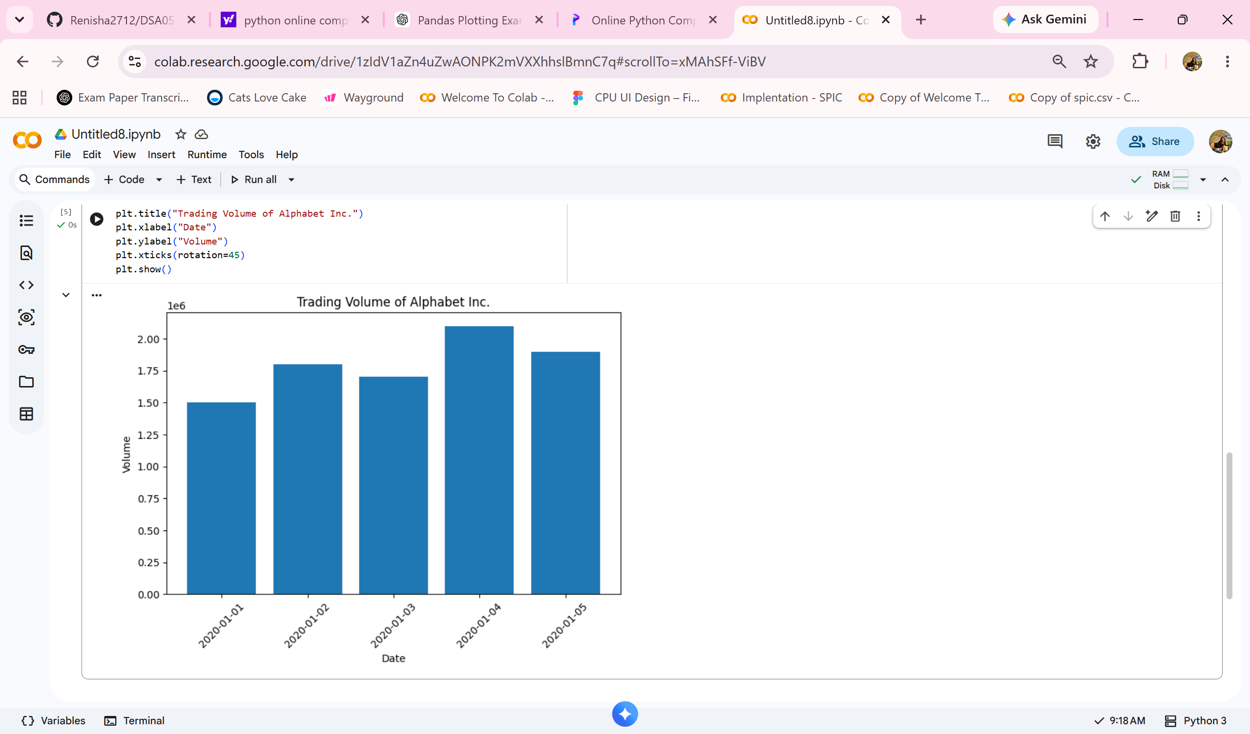
6.import pandas as pd
import matplotlib.pyplot as plt
data = {
"Date": ["2020-01-01","2020-01-02","2020-01-03","2020-01-04","2020-01-05"],
"Close": [1367, 1375, 1382, 1390, 1401],
"Volume": [1500000, 1800000, 1700000, 2100000, 1900000]
}
df = pd.DataFrame(data)
df["Date"] = pd.to_datetime(df["Date"])
plt.figure(figsize=(8,5))
plt.scatter(df["Volume"], df["Close"])
plt.title("Trading Volume vs Stock Price")
plt.xlabel("Trading Volume")
plt.ylabel("Closing Price")
plt.show()

